User manual for a work machine



______________________________

Summary

* **Presentation of the work machine**
  + Description and explanation of the machine 3
  + Machine components 5
* **Functionality** 
  + Basic functionality 6
  + Advanced functionality 9
* **Languages and date**
  + machine settings 10
  + keyboard settings 10

________________________________

1**-Presentation**

**Description :**

This machine uses a free operating system called Debian, works with this graphic interface. Practically all things that we do with this machine are done with commands in a terminal.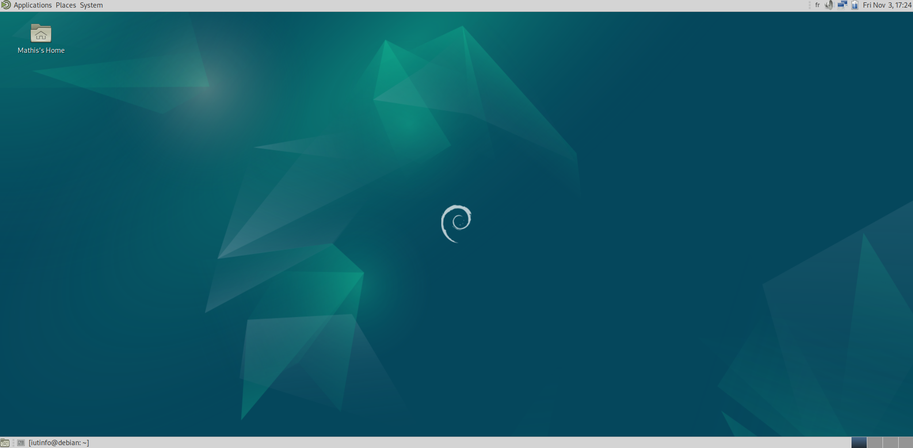

It’s configurable with command and settings allowing a big customization.

There are two types of users : normal-users and a special-user called Super-user or Root who has all rights on the machine. To connect yourself as a root you have to open a terminal **(ctrl+alt+t)** and type **“su -”**, **the basic password is root**

(it will not display the password to keep a good security)

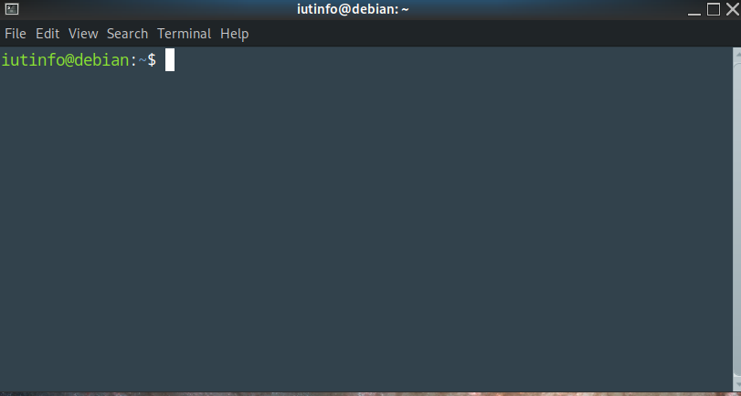

A terminal

look like that →

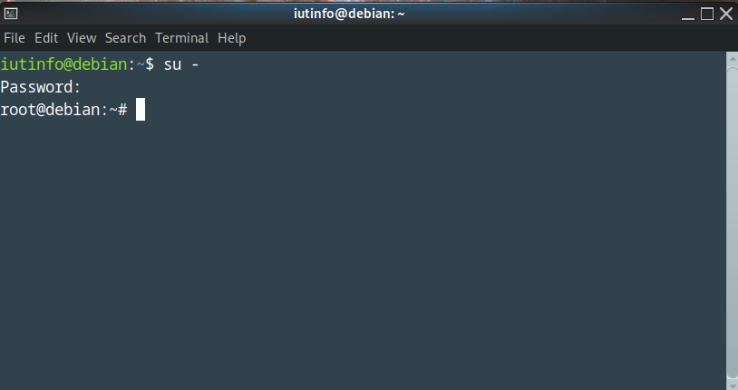

when you are

on root like that →

it's better to add all right to a user temporary than always go on root To add all right write **“usermod -aG sudo (user)”**

then restart the machine.

**Machine Components :**

to see Components open a terminal and write **“sudo apt install hardinfo”**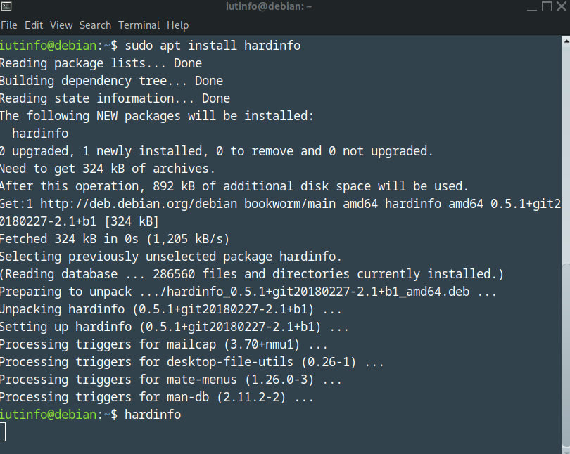

Enter **“hardinfo”**, this command open a window with components

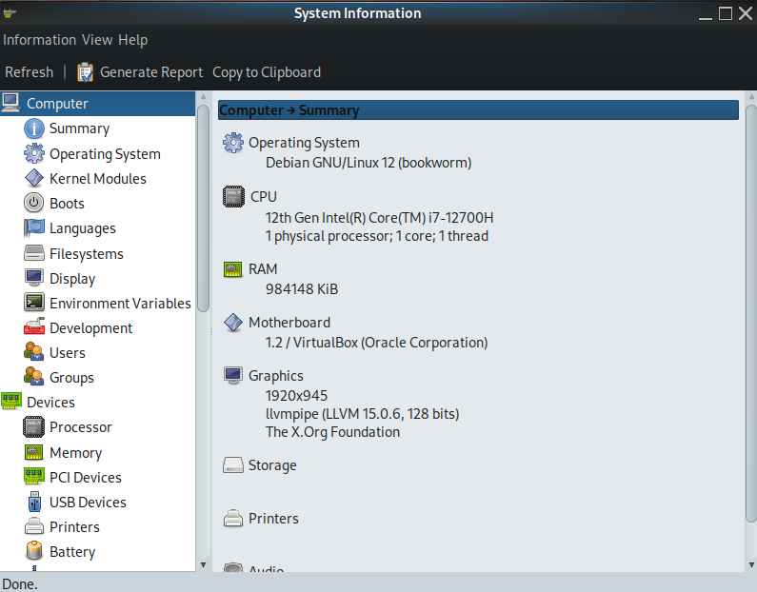

________________________________

**2-Functionality**

**functionality :**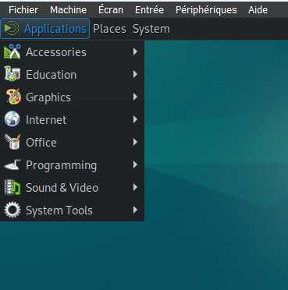

To launch any application

installed on Debian, simply

click on the menu at the top left

and go to the right category to launch it.

**Users/ Groups Settings**

**In terminal** 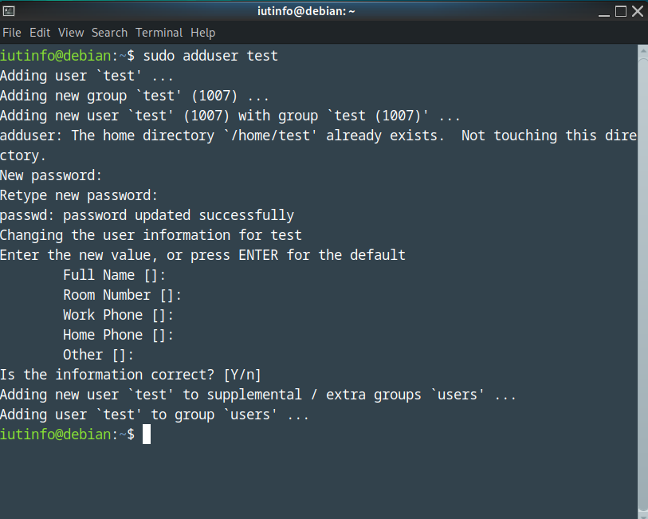

Create user you need to type

**“sudo adduser (name)”**

and follow instructions.

To create a group :

**“sudo groupadd (grp-name)”**

Add a user to a group :

**“sudo gpasswd -a (user)(group)”**

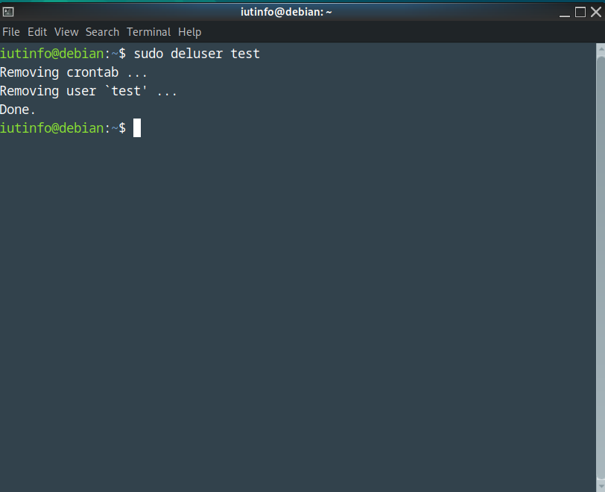

Delete a user :

**“sudo deluser (name)”**

Delete a group :

**“sudo groupdel (grp-name)”**

Remove a user from a group :

**“sudo gpasswd -d (user)(group)”**

**Install any application**

Install an application on Debian : it's easy because Debian has a bank of applications,

(all the application in this bank with this link)

<https://packages.debian.org/fr/stable/allpackages>

To install any application in this bank type **“sudo apt install (app-name)”**

To install any application not in the bank you need to download a package-manager called "snap".

**(A package-manager keeps track of the programs installed on your computer. it makes it easy to install new programs, update or remove programs).**

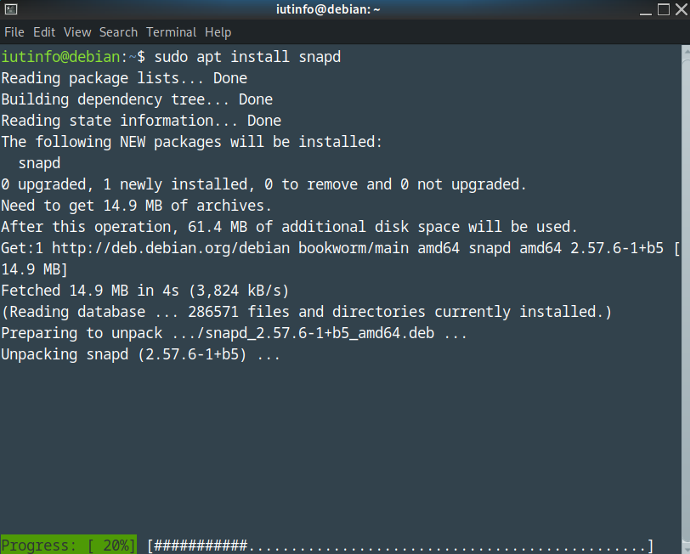

To install snap open a terminal and

type **“sudo apt install snapd”**

To see if the application that you

want is on snap, in a terminal

type **“snap find (app-name)”**

Example with firefox

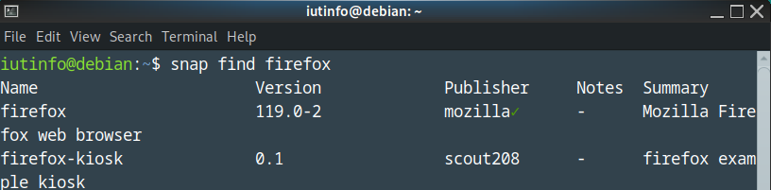

If snap return there is

an application you can install

it by the command :

**“sudo snap install (app-name)”**

**uninstall any application**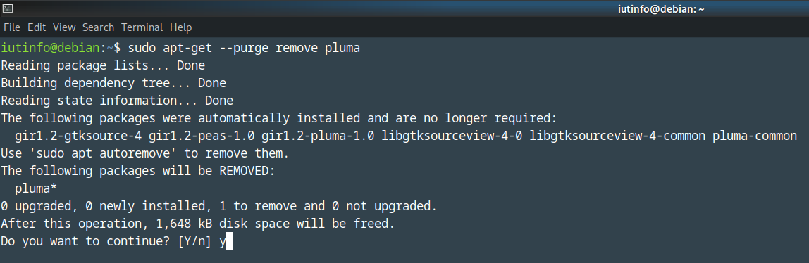

Uninstall an application who is in

Debian bank you just need to type :

**“sudo apt-get --purge remove (app-name)**

Uninstall an application installed from

snap : **“sudo snap remove (app-name)”**

**Terminal**

Directly in terminal you can get help with many command by typing **“man (command-name)”** 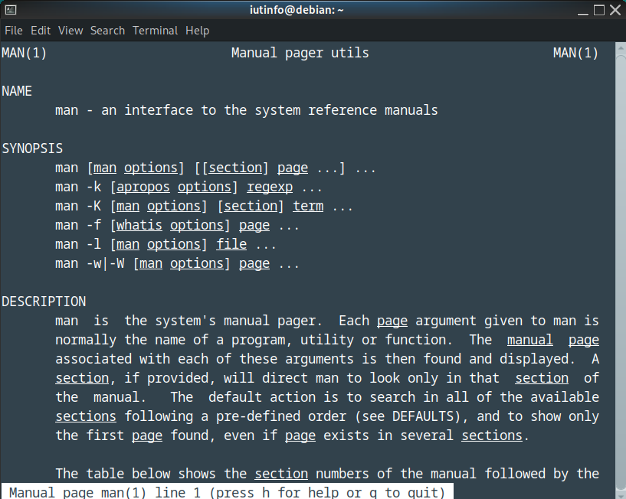

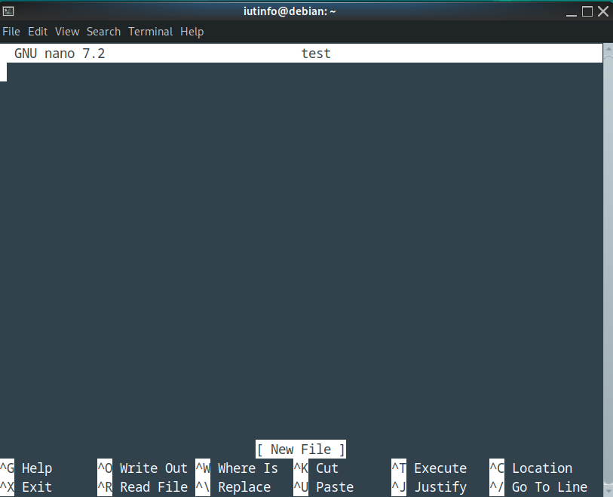

you can open a text editor

fully configurable

called **“nano”**

**Advanced functionality :**

Disk partitioning consists of cutting the disk and formatting it to accommodate files that will not be in the same location. There are two type of partitioning : main partition and extended partition

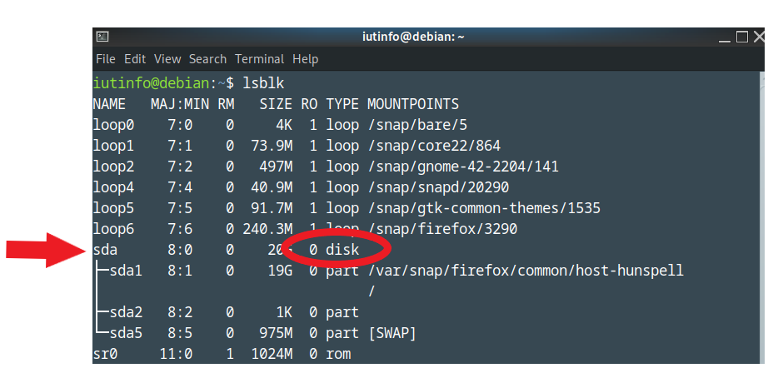

You can see all partition of

your disk by typing **“lsblk”**

create new partition :

**“sudo fdisk /dev/(sda)”**

**(replace with the word**

**next to the arrow)**

________________________________

**3-Languages and dates**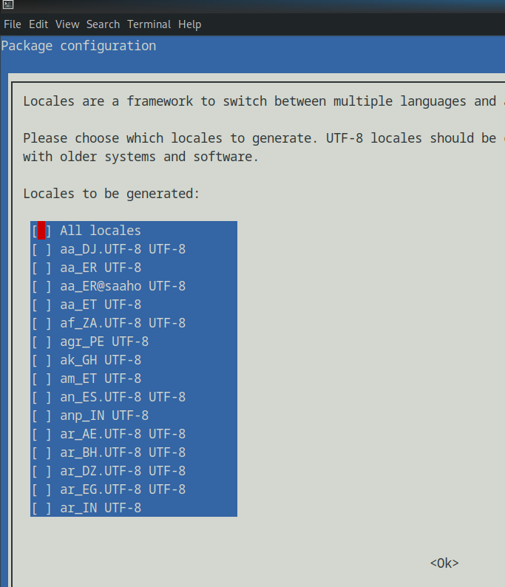

**Machine settings :**

To change the machine language :

**“sudo dpkg-reconfigure locales”**

And to change the machine date :

**“sudo dpkg-reconfigure tzdata”**

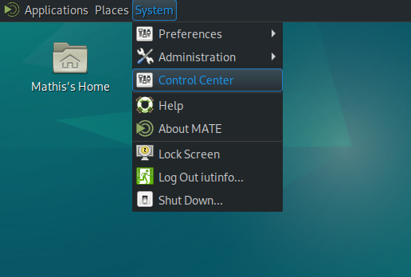

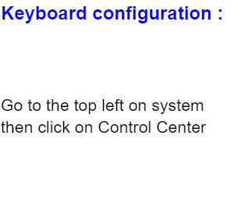

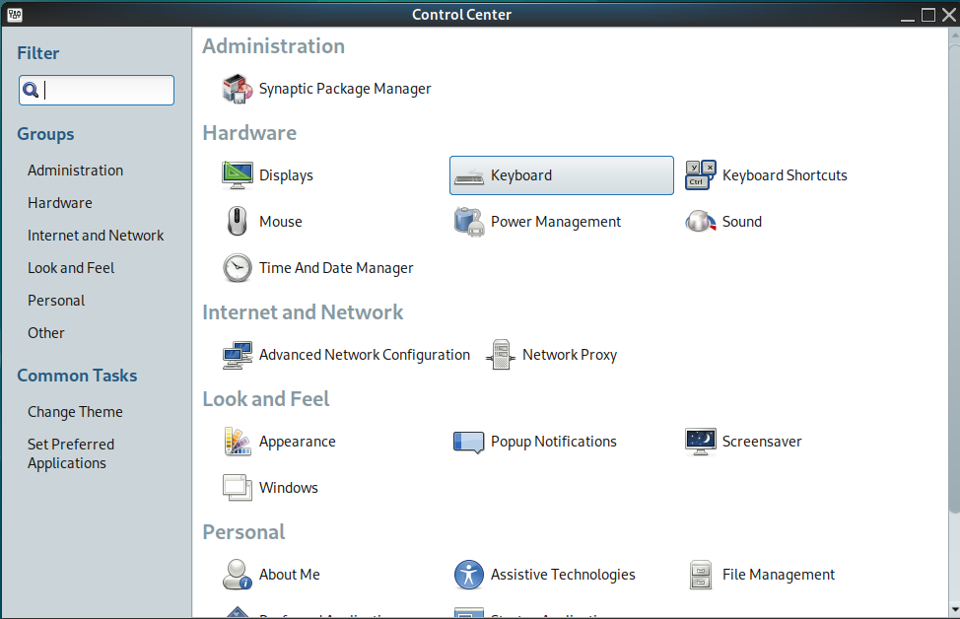

Then on Keyboard →

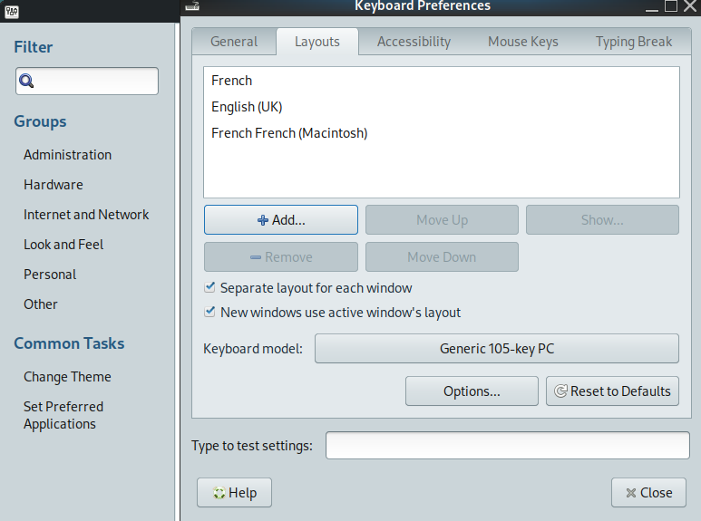

click Layout and **“+Add” →**

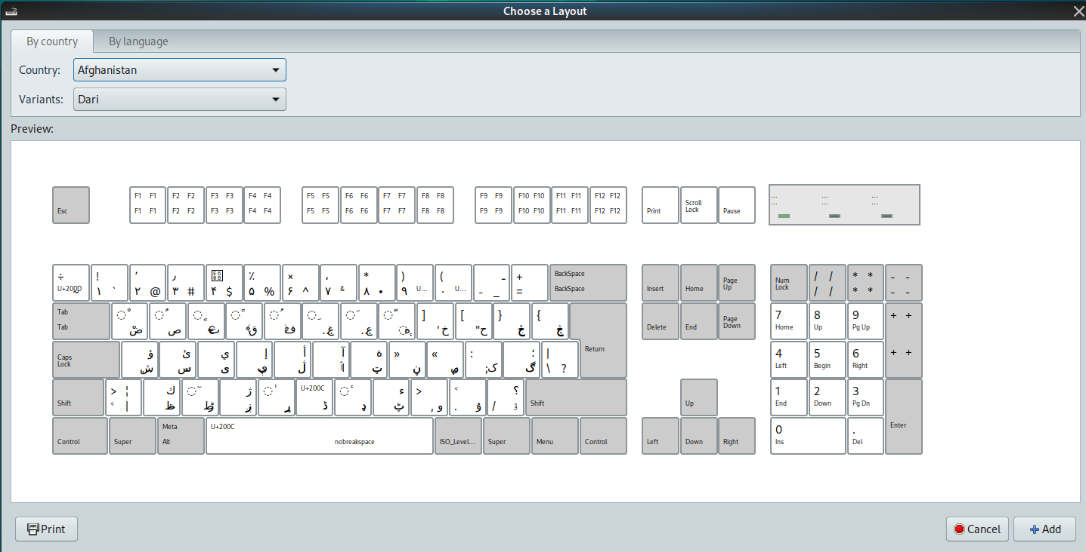

And choose your

keyboard configuration

**Mathis Magnier**

**Tom Dequesnes** 595 words